# Observations:

In both cases, the same basic information is entered.

For in-house, gov funding and beneficiaries are listed up front while for volunteer and consultants, they are entered on the SM. Financial Contributors are always entered on the SM.

Why? I assume an In-house effort is focused on a particular item. While consultants and volunteers and work on a wide range of SMs.

Note: The java code, call SMs: undertakings.

POH communications doesn't occur unless the SM is "approved" and has become active. The user goes into the system and 'updates' the SM and adds the communication

Consultants and Volunteers lobby on behalf of clients, while in-house lobbyist lobby on behalf of beneficiaries, which are related firms. But C&V can also have additional beneficiaries.

# Consultant Registration

* Add name and business info
* Mark if person has held office at city previously
* Enter firm details
  + There is no other beneficiaries or related firms
* Enter delegate if applicable

# SM for Consultant

* Add one or more subject matter, Enter start and date of effort
* Enter Client
* Enter: other beneficiaries: parent co, subsidiary, coalition member controlling interest holder, and other related company.
* Enter financial contributors (non-government)
* Enter government funding
* Enter grass roots.

# In House Registration

* Enter a senior officer (as registrant) and address info
* Identify if officer previously worked at City
* Enter Business name/Trade Name and address
* Beneficiaries as related firms who benefit from lobbyist activities.
* Add committees (if the if business type is Professional/Labour Association, Business Industry Trade, or Not for Profit grant application (last 3 entries in the dropdown)
* Add a delegate if desired
* Enter description of business activities, fiscal start and end
* List other beneficiaries, which are related companies (parent, subsidiary or other
* Add in any government funding if applicable (Note there is no option to add at a SM level)
* Add in additional 'in-house lobbyist'. Associated of the senior officer
* Add Notes

# SM for In-House

* Add one or more subject matters, Enter start and date of effort
* Enter zero, one or more financial contributors (non-gov)
* Assign one or more in-house lobbyist (one defined in the registration form)
  + Presumable, if a new lobbyist is added, the registration must be amended, then the SM amended.
* Add grass roots communication (if required)
* Add committee meetings (if committee information was entered and registration is approved)
* Add optional notes

Once you fo lobbying efforts, you log them by changing the SM and add POH communications

# Volunteer Registration

* Enter Lobbyist information and address
* Add firm information
* Add delegate if desired
* Optional notes

# Create Volunteer SM (same as 'Consultant')

* select one or more subject matters, specifics of effort and time frame of effort
* add in client details .. Including contact and fiscal year.
* Add in other beneficiaries (My client has parent corporation(s) or subsidiary corporation(s) or other related corporations that have a direct interest or stand to benefit from this lobbying activity)
* Add in financial contributors (non- gov)
* Add in Government Funding
* Add in Grass Roots
* Add optional notes

**5736693616 consultant**

**5736762580 - in house lobbyist**

**SM21629 – for in house**

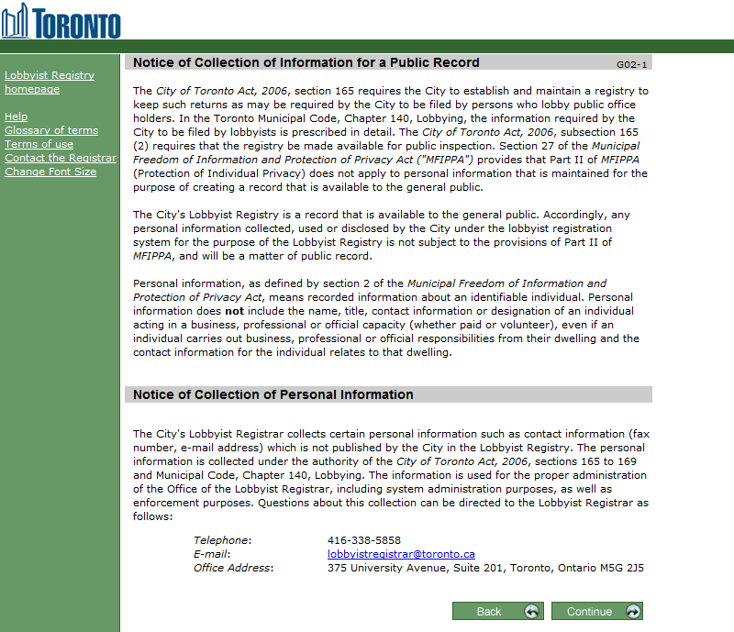

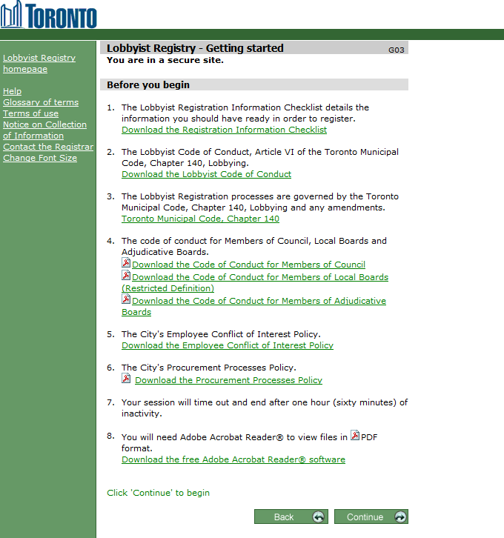

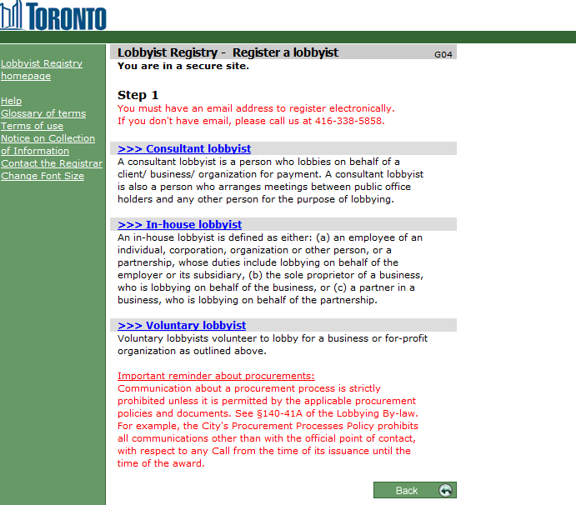

Consultant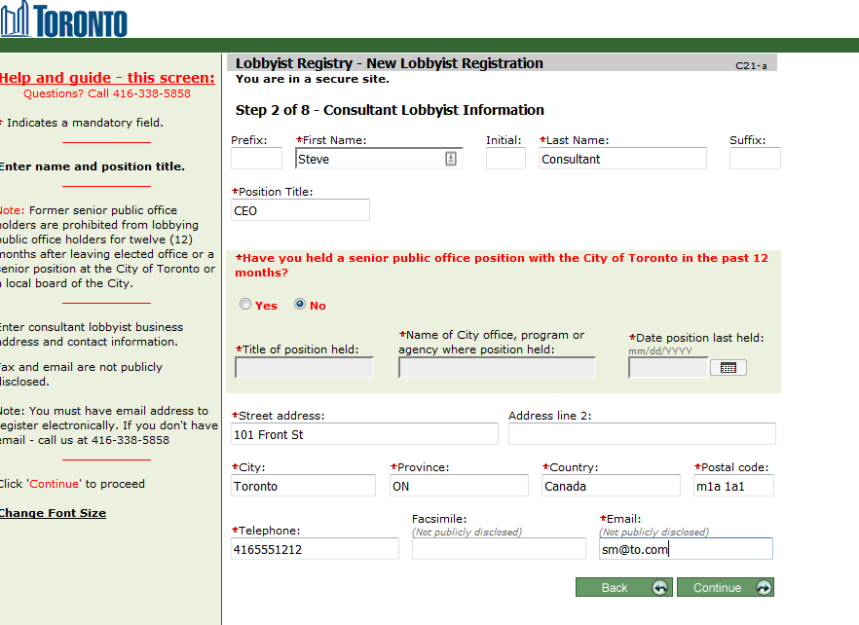

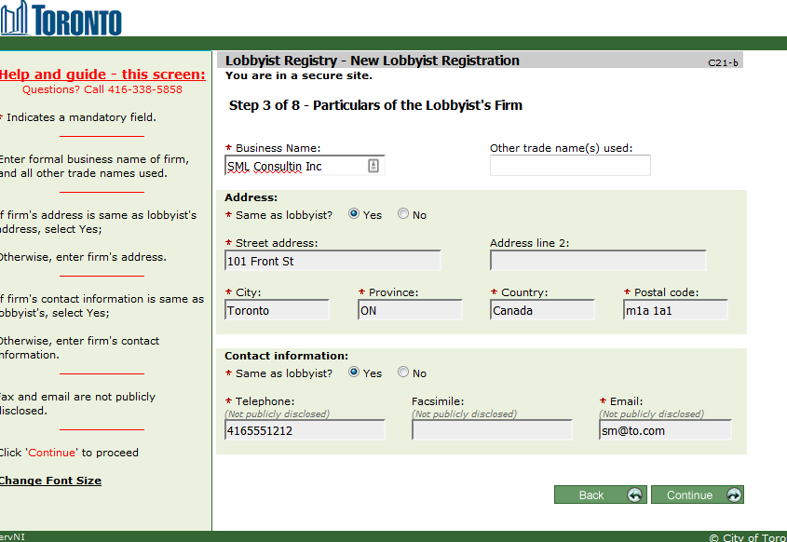

I've never seen a delegate in the data.

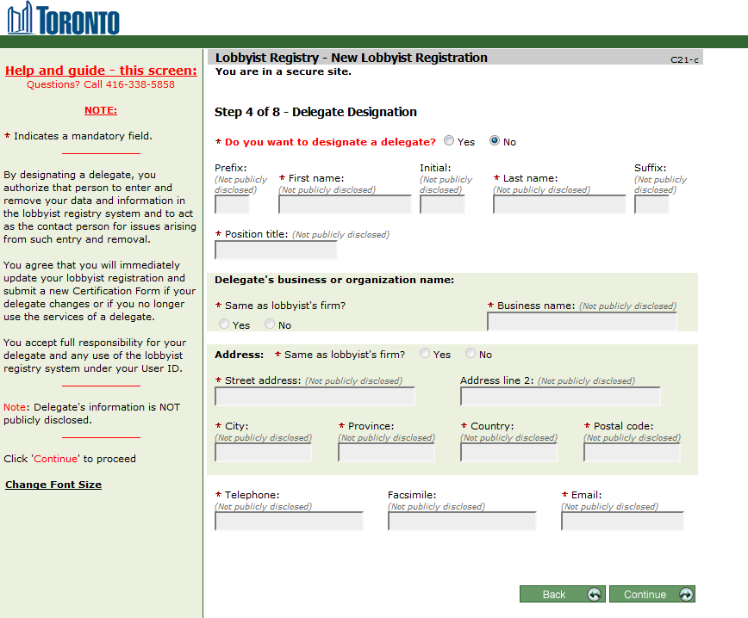

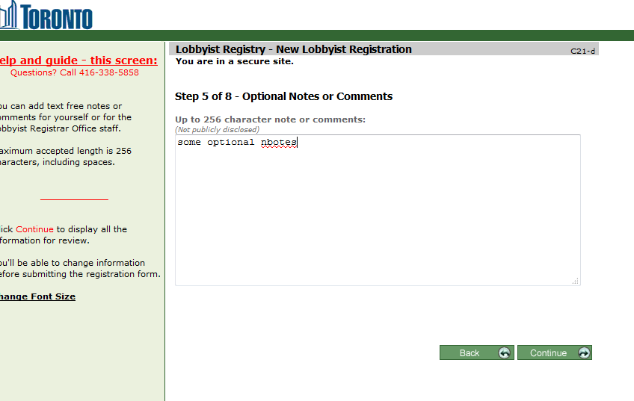

Steps 6,7 password id stuff and confirmation

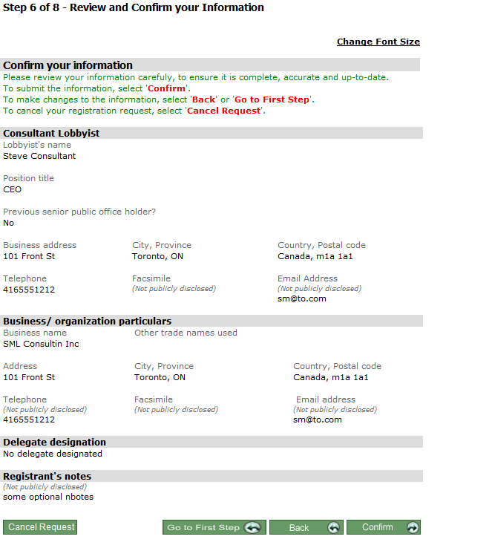

## SM for Consultant:

* Add one or more subject matter, Enter start and date of effort
* Enter Client
* Enter: other beneficiaries: parent co, subsidiary, coalition member controlling interest holder, and other related company.
* Enter financial contributors (non-government)
* Enter government funding
* Enter grass roots.

Screen prints not added.. see volunteer

# In House Lobbyist Registration

* Enter a senior officer (as registrant) and address info
* Identify if officer previously worked at City
* Enter Business name/Trade Name and address
* Beneficiaries as related firms who benefit from lobbyist activities.
* Add a delegate if desired
* Enter description of business activities, fiscal start and end
* List other beneficiaries, which are related companies (parent, subsidiary or other
* Add in any government funding if applicable
* Add in additional 'in-house lobbyist'. Associated of the senior officer
* Add Notes

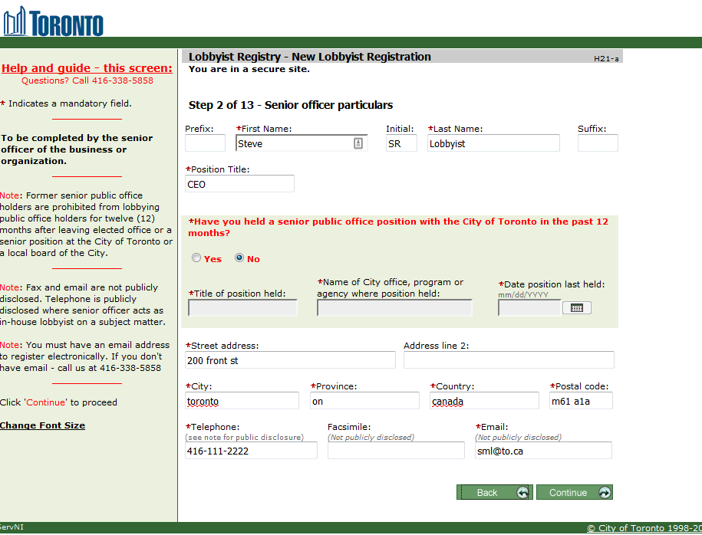

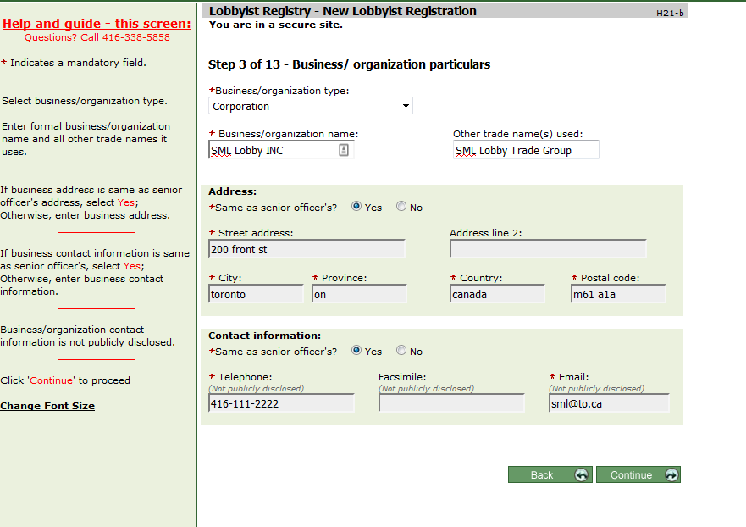

No step 4…?? Well Yes actually if business type is

Professional/Labour Associtation

Business Industry Trade

Not for Profit grant application

(last 3 entries in the dropdown) then you can enter committee information

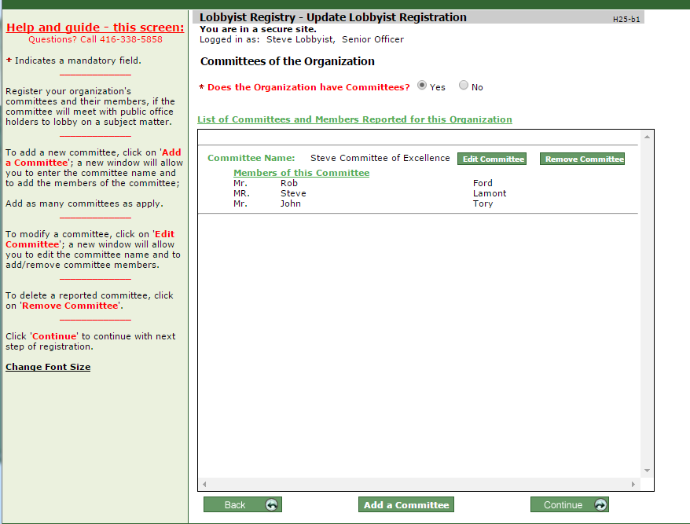

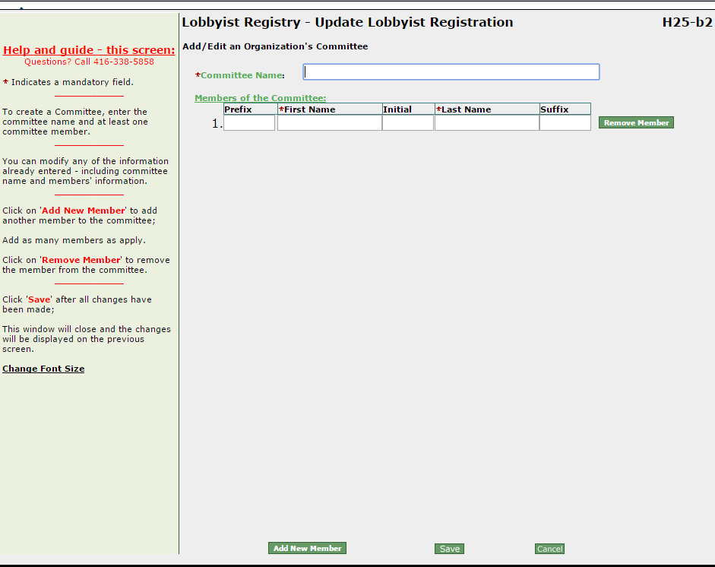

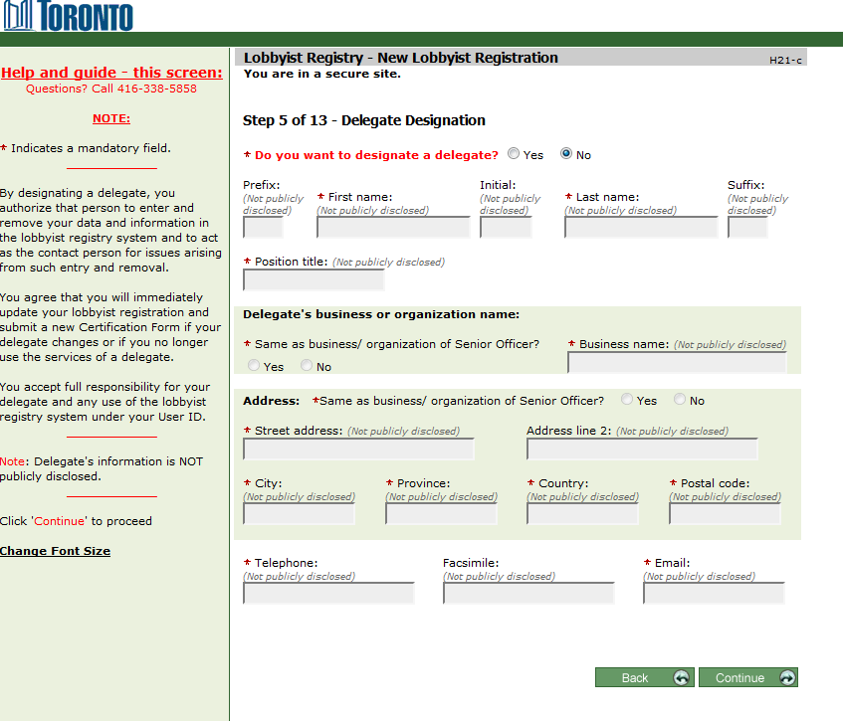

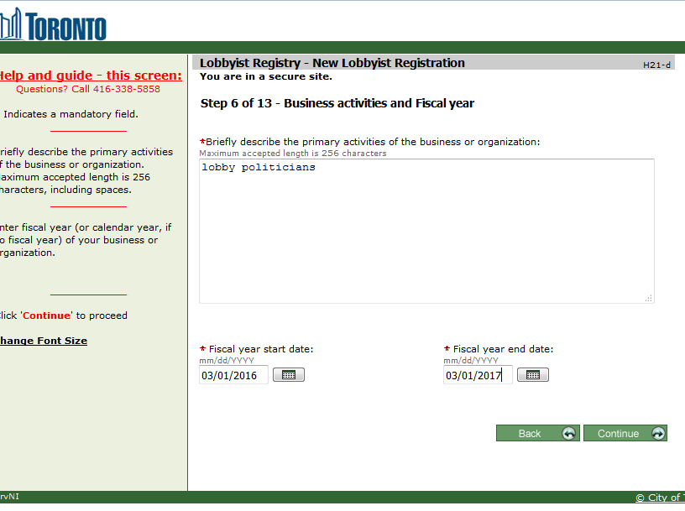

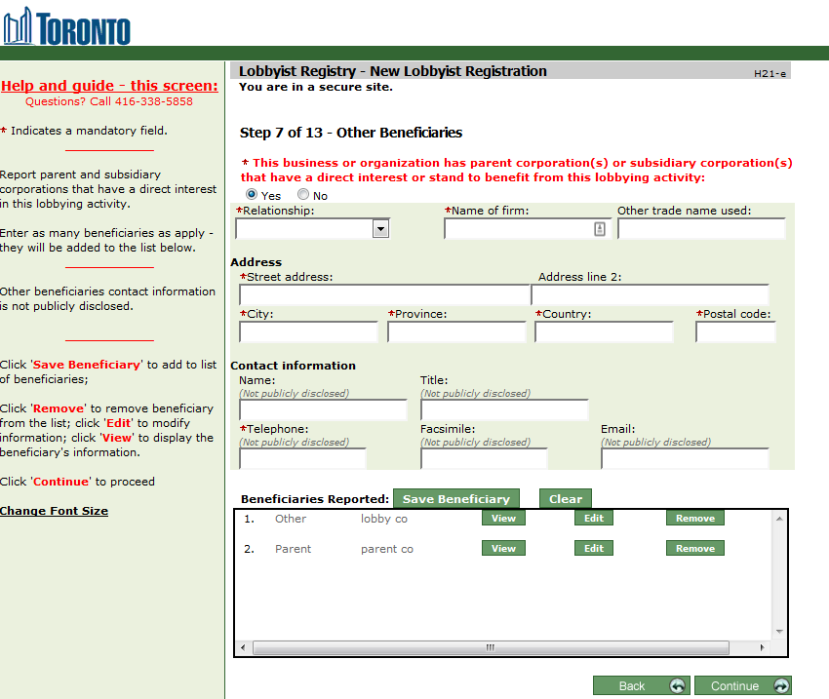

Relationship: Other, Parent, subsidiary.

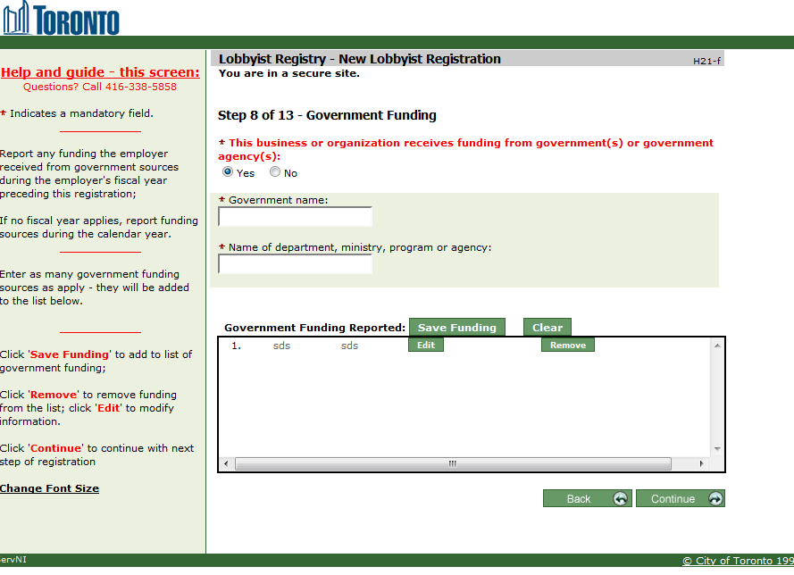

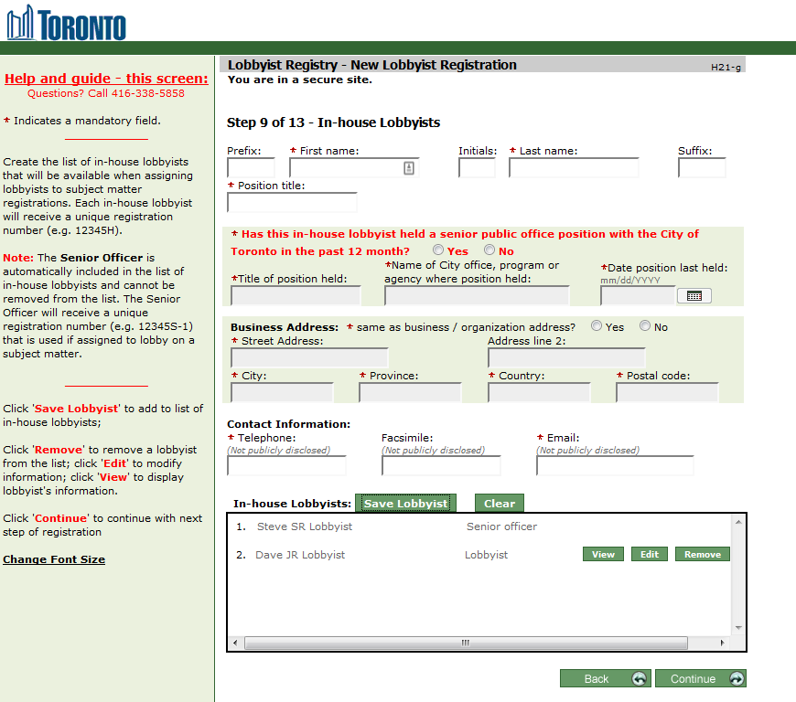

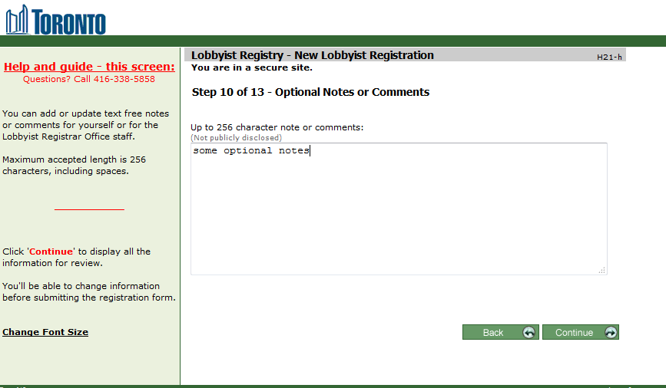

## Create SM Particulars for In-House

* Add one or more subject matters
* Enter start and date of effort
* Enter zero, one or more financial contributors (non-gov)
* Assign one or more in-house lobbyist (one defined in the registration form)
  + Presumable, if a new lobbyist is added, the registration must be amended, then the SM amended.
* Add grass roots communication (if required)
* Add optional notes

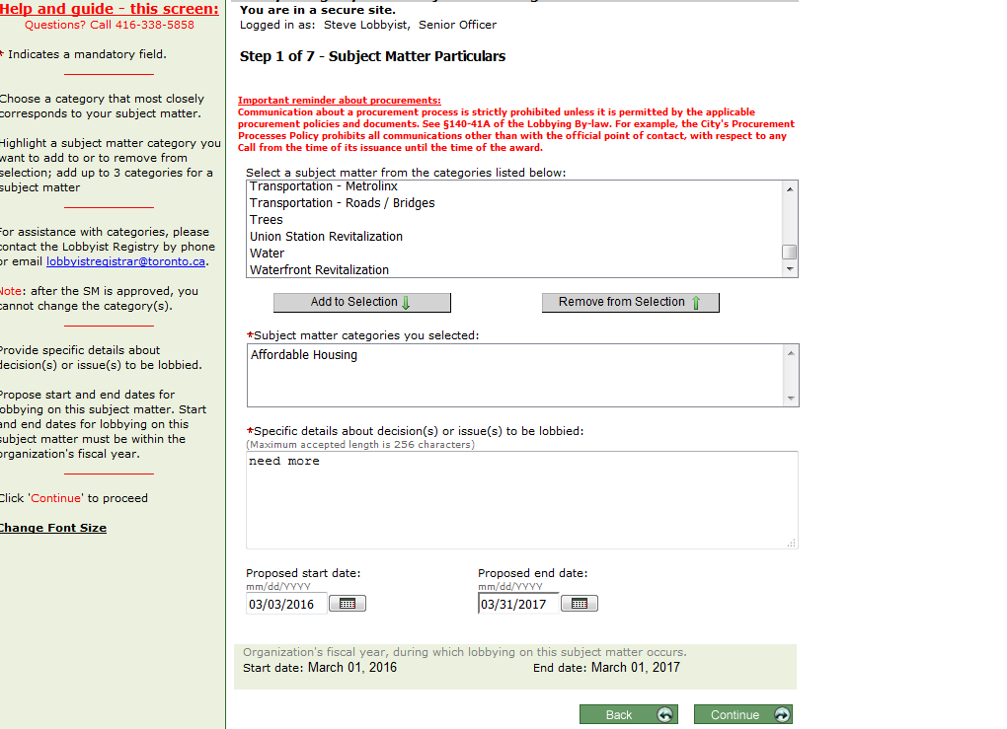

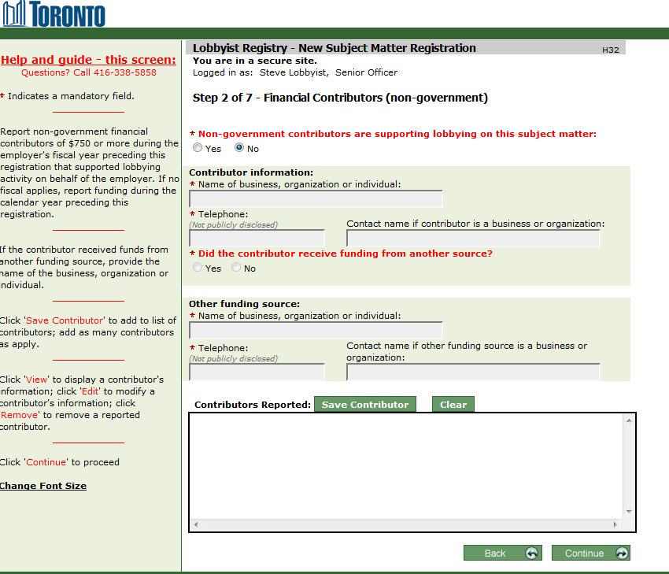

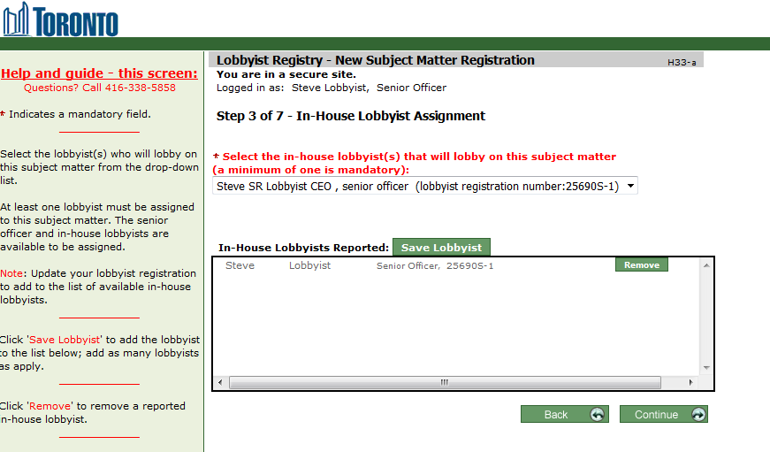

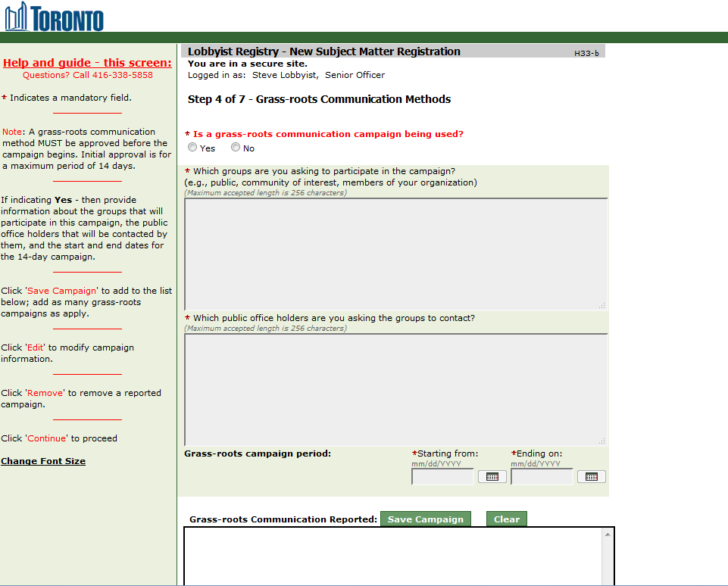

If committee information is entered (and approved) then committee communication can be added.

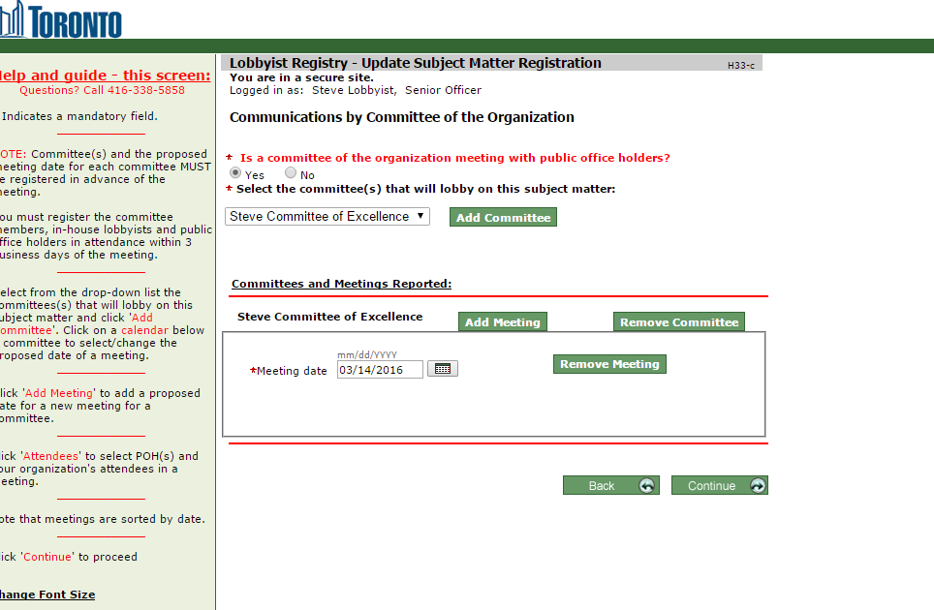

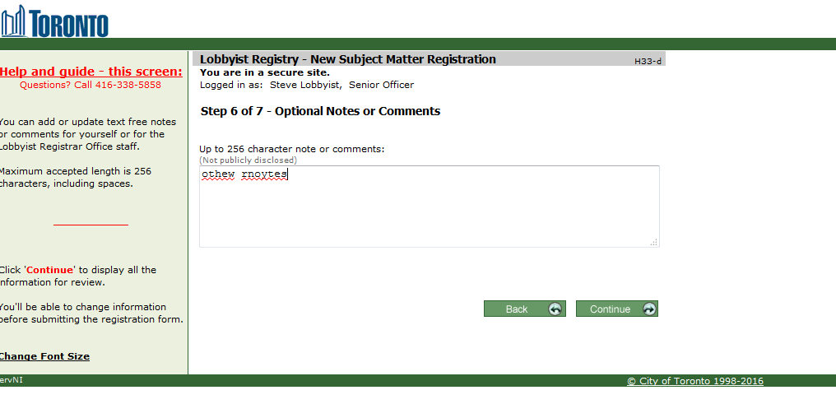

When updating SM and after approval:

You record who you lobbied and method

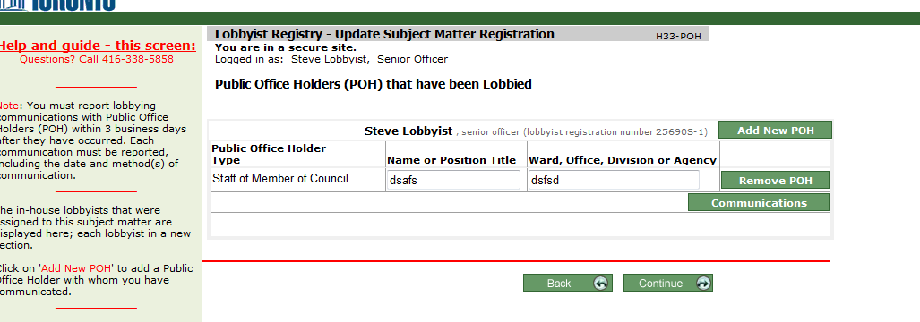

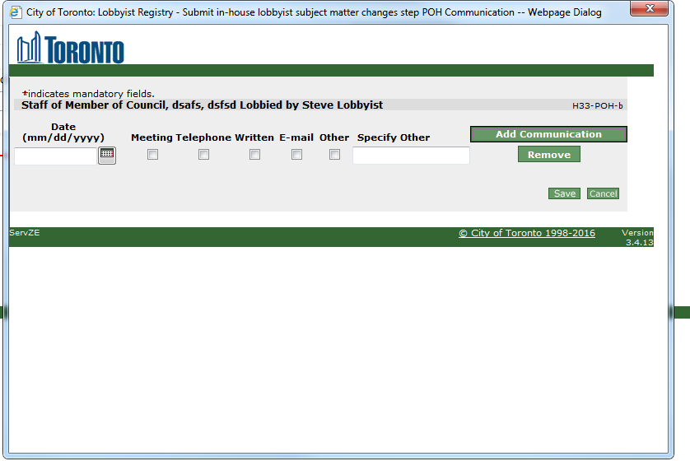

I don't know how commitee meetings are entered

# Volunteer Registration

* Enter Lobbyist information and address
* Add firm information
* Add delegate if desired
* Optional notes

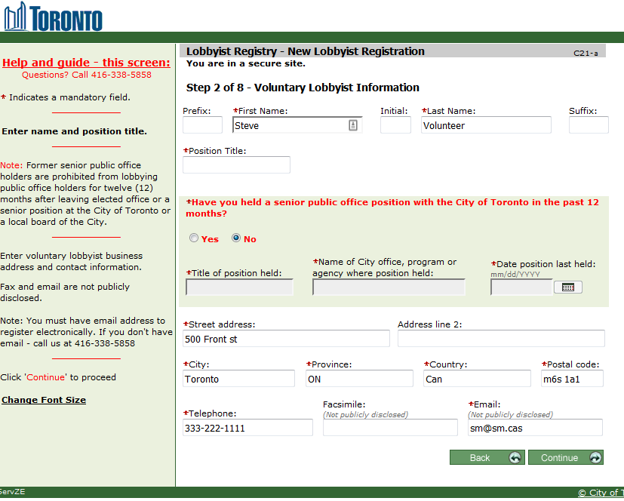

No step 3.. 1st time but it is there

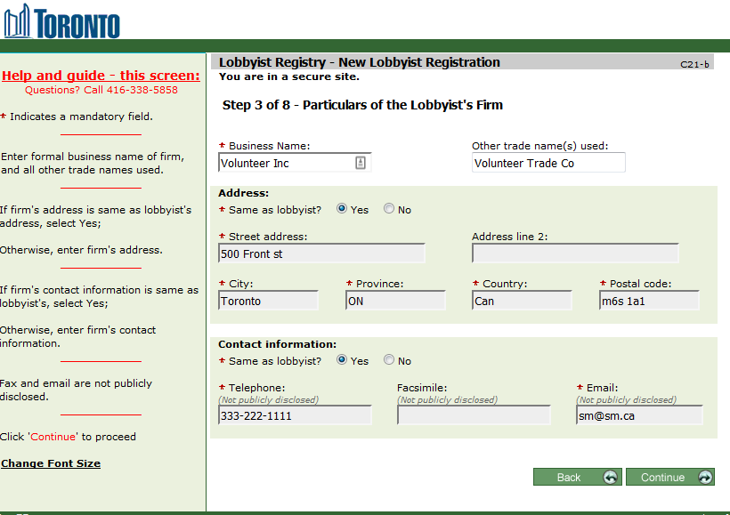

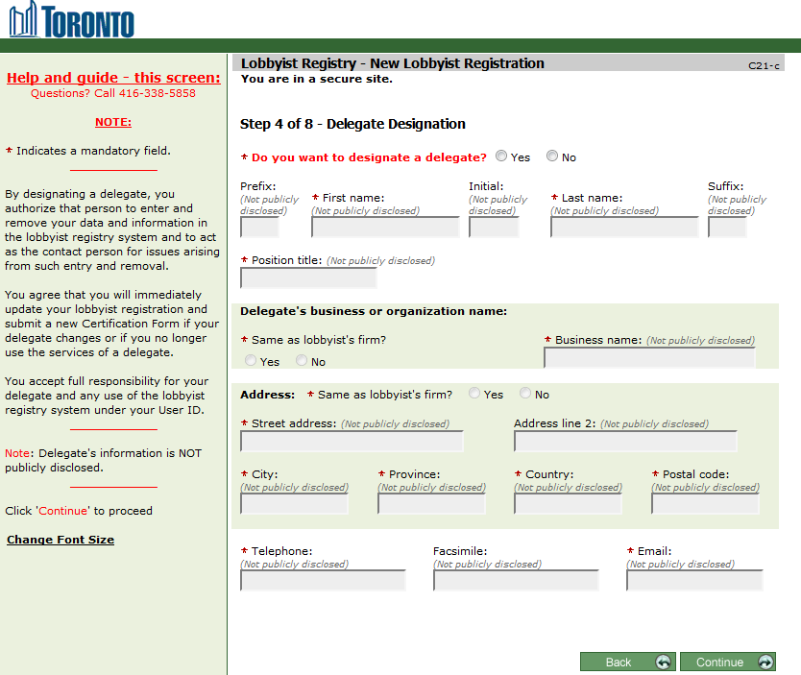

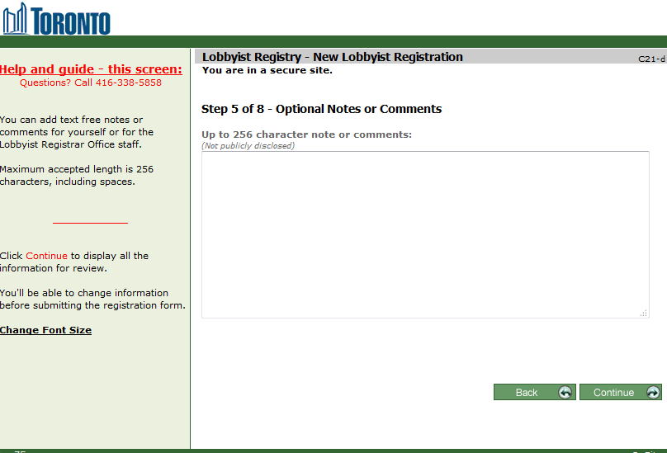

Review/Confirm/Password (6,7,8)

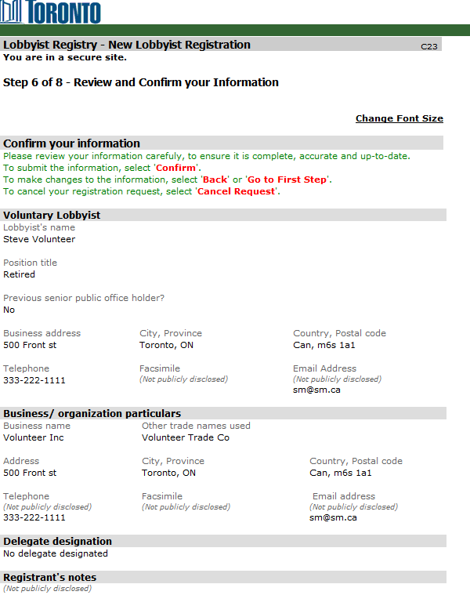

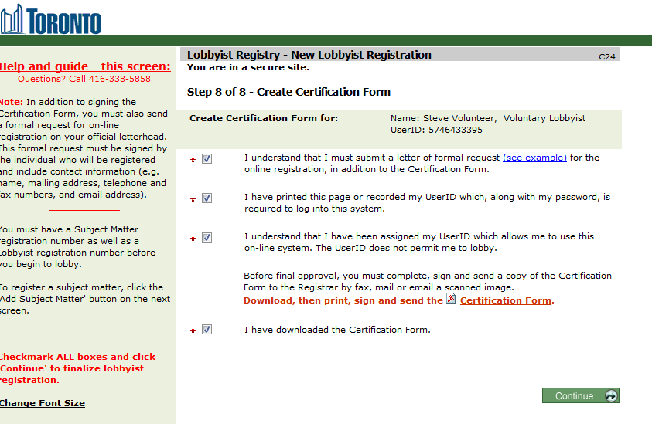

# Create Volunteer SM

* select one or more subject matters, specifics of effort and time frame of effort
* add in client details .. including contact and fiscal year.
* Add in other beneficiaries (My client has parent corporation(s) or subsidiary corporation(s) or other related corporations that have a direct interest or stand to benefit from this lobbying activity)
* Add in financial contributors (non- gov)
* Add in Government Funding
* Add in Grass Roots
* Add optional notes

